

**Tech Saksham**

Case Study Report

Data Analytics with Power BI

**“supply chain Analysis of**

**inventories”**

**“Sacred Heart College of Arts and Science**

**Dindigul ”**

|  |  |
| --- | --- |
| **NM ID** | **NAME** |

CEC451228F5CB79A9D44A

6ED8BB65E7F VEERAN.C

|  |  |
| --- | --- |
| **Trainer name** | **Master name** |
|  |  |
| **R.UMAMAGESHWAR** | **R.UMAMAGESHARI** |
| **I** |  |





**ABSTRACT**

The "Supply Chain of Analytics" initiative, utilizing PowerBI, has underscored the critical role of data analytics in transforming the industry. By delving into the intricacies of the supply chain, including aspects such as customer demographics, product details, sales figures, promotional strategies, and overall financial transactions, it has unearthed invaluable insights. The development of dynamic dashboards and comprehensive reports has revolutionized the approach to customer data analysis, revealing patterns and connections that were not apparent before. This breakthrough has streamlined the analytical process, significantly enhancing the company's ability to provide personalized services, pinpoint opportunities for upselling and cross-selling, and refine their product offerings to more closely meet customer needs. Additionally, this project is instrumental in advancing the broader goal of digital transformation within the banking sector, promoting greater efficiency, fostering innovation, and placing a renewed emphasis on addressing the needs of customers.



**INDEX**

|  |  |  |
| --- | --- | --- |
| **Sr. No.** | **Table of Contents** | **Page No.** |
|  |  |  |
| 1 | Chapter 1: Introduction | 4 |
|  |  |  |
| 2 | Chapter 2: Services and Tools Required | 6 |
|  |  |  |
| 3 | Chapter 3: Project Architecture | 7 |
|  |  |  |
| 4 | Chapter 4: Modeling and Result | 9 |
|  |  |  |
| 5 | Conclusion | 18 |
|  |  |  |
| 6 | Future Scope | 19 |
|  |  |  |
| 7 | References | 20 |
|  |  |  |
| 8 | Links | 21 |
|  |  |  |



**CHAPTER 1**

**INTRODUCTION**

**1.1 Problem Statement**

In today’s competitive product landscape, understanding customer behavior and preferences is crucial for customer retention and revenue generation. However, products often face challenges in analyzing customer data due to the sheer volume and velocity of data generated. Traditional data analysis methods are time-consuming and often fail to provide supply chain insights. This lack of supply chain analysis can lead to missed opportunities for customer engagement, cross-selling, and up-selling, impacting the product’s revenue generation and customer satisfaction. Furthermore, the complexity and diversity of customer data, which includes transaction history, customer feedback, and demographic data, pose additional challenges for data analysis.

**1.2 Proposed Solution**

The proposed solution is to develop a PowerBI dashboard that can analyze and visualize real-time customer data. The dashboard will integrate data from various sources such as transaction history, customer feedback, and demographic data. It will provide a comprehensive view of customer behavior, preferences, and trends, enabling banks to make informed decisions. The dashboard will be interactive, user-friendly, and customizable, allowing products to tailor it to their specific needs. The supply chain analysis capability of the dashboard will enable banks to respond promptly to changes in customer behavior or preferences, identify opportunities for cross-selling and up-selling, and tailor their products and services to meet customer needs.

**1.3 Feature**

* **Supply Chain Analysis**: The dashboard will provide supply chain analysis of customer data.
* **Customer Segmentation**: It will segment customers based on various parameters like age,income, transaction behavior, etc.

**© Edunet Foundation. All rights reserved** |4

* **Trend Analysis**: The dashboard will identify and display trends in customer behavior.
* **Predictive Analysis**: It will use historical data to predict future customer behavior.

**1.4 Advantages**

* **Data-Driven Decisions**: products can make informed decisions based on supply chain dataanalysis.
* **Improved Customer Engagement**: Understanding customer behavior and trends can help toengage with their customers more effectively.
* **Increased Revenue**: By identifying opportunities for cross-selling and up-selling, market canincrease their revenue.

**1.5 Scope**

The scope of this project extends to all banking institutions that aim to leverage data for decision-making and customer engagement. The project can be further extended to incorporate more data sources and advanced analytics techniques, such as machine learning and artificial intelligence, to provide more sophisticated insights into customer behavior. The project also has the potential to be adapted for other sectors, such as retail, healthcare, and telecommunications, where understanding customer behavior is crucial. Furthermore, the project contributes to the broader goal of digital transformation in the product market sector, promoting efficiency, innovation, and customer-centricity.

**CHAPTER 2**

**SERVICES AND TOOLS REQUIRED**

**2.1 Services Used**

**© Edunet Foundation. All rights reserved** |5



* **Data Collection and Storage Services**: product need to collect and store customer datain supply chain. This could be achieved through services like Azure Data Factory, Azure Event Hubs, or AWS Kinesis for real-time data collection, and Azure SQL Database or AWS RDS for data storage.
* **Data Processing Services**: Services like Azure Stream Analytics or AWS Kinesis DataAnalytics can be used to process the real-time data.
* **Machine Learning Services**: Azure Machine Learning or AWS SageMaker can beused to build predictive models based on historical data.

**2.2 Tools and Software used**

**Tools**:

* **PowerBI**: The main tool for this project is PowerBI, which will be used to createinteractive dashboards for real-time data visualization.
* **Power Query**: This is a data connection technology that enables you to discover,connect, combine, and refine data across a wide variety of sources.

**Software Requirements**:

* **PowerBI Desktop**: This is a Windows application that you can use to create reportsand publish them to PowerBI.
* **PowerBI Service**: This is an online SaaS (Software as a Service) service that you useto publish reports, create new dashboards, and share insights.
* **PowerBI Mobile**: This is a mobile application that you can use to access your reportsand dashboards on the go.

**© Edunet Foundation. All rights reserved** |6

**CHAPTER 3**

**PROJECT ARCHITECTURE**

**3.1 Architecture**

Here’s a high-level architecture for the project:

1. **Data Collection**: supply chain customer data is collected from various sources likeproduct transactions, customer interactions, etc. This could be achieved using services like Azure Event Hubs or AWS Kinesis.
2. **Data Storage**: The collected data is stored in a database for processing. Azure SQLDatabase or AWS RDS can be used for this purpose.
3. **Data Processing**: The stored data is processed in real-time using services like AzureStream Analytics or AWS Kinesis Data Analytics.
4. **Machine Learning**: Predictive models are built based on processed data using AzureMachine Learning or AWS SageMaker. These models can help in predicting customer behavior, detecting fraud, etc.
5. **Data Visualization**: The processed data and the results from the predictive models arevisualized in real-time using PowerBI. PowerBI allows you to create interactive dashboards that can provide valuable insights into the data.
6. **Data Access**: The dashboards created in PowerBI can be accessed through PowerBIDesktop, PowerBI Service (online), and PowerBI Mobile.

This architecture provides a comprehensive solution for real-time analysis of bank customers. However, it’s important to note that the specific architecture may vary depending on the bank’s existing infrastructure, specific requirements, and budget. It’s also important to ensure that all tools and services comply with relevant data privacy and security regulations.

**© Edunet Foundation. All rights reserved** |7



**CHAPTER 4**

**MODELING AND RESULT**

**Manage relationship**

The “disp” file will be used as the main connector as it contains most key identifier (account id, client id and disp id) which can be use to relates the 8

**© Edunet Foundation. All rights reserved** |8

data files together. The “district” file is use to link the client profile

geographically with “district id”

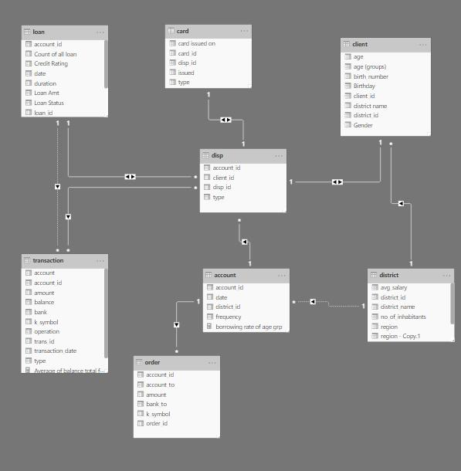

**© Edunet Foundation. All rights reserved** |9

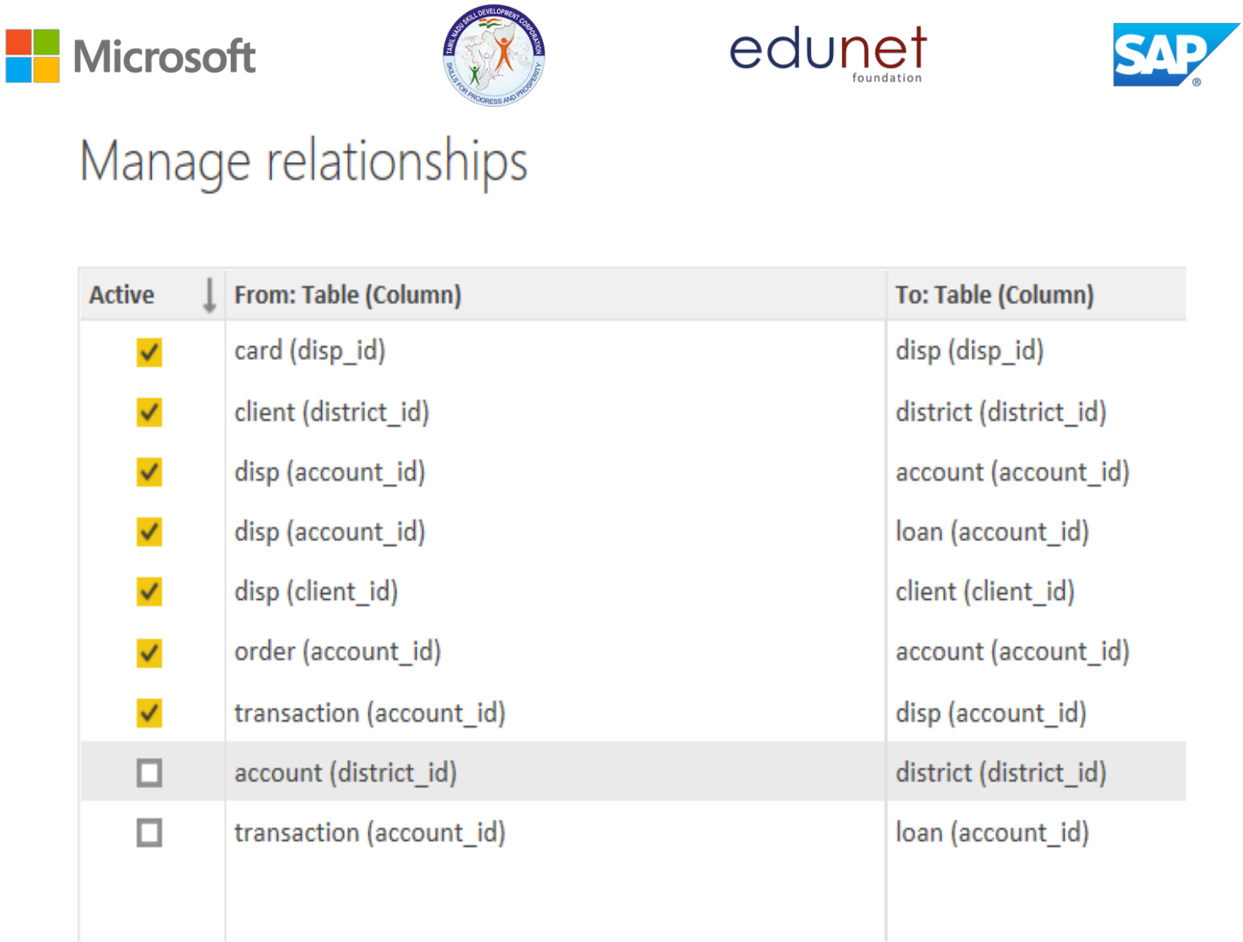

**© Edunet Foundation. All rights reserved** |10

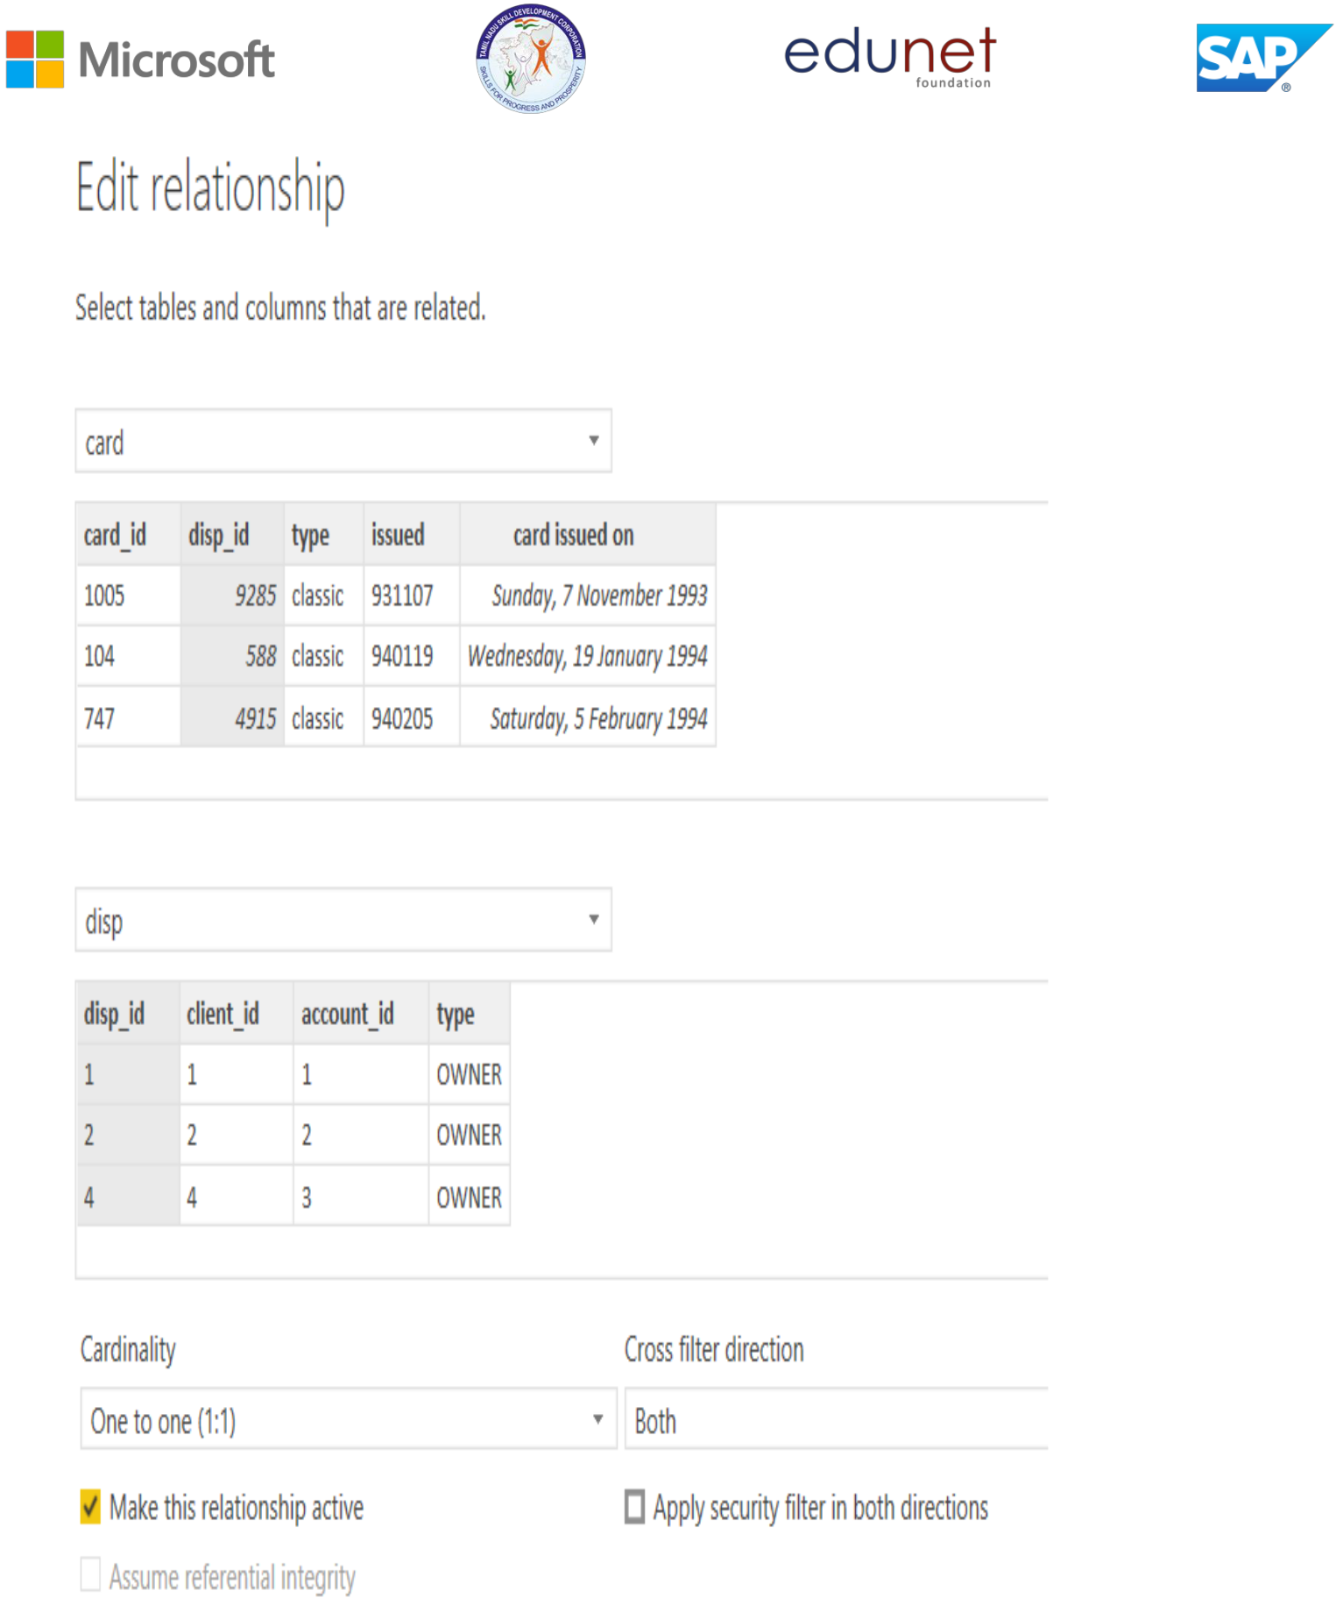

**Modelling for Gender and Age data**

Notice that the Gender and age of the client are missing from the data. These can be formulated from the birth number YYMMDD where at months (the 3rd

**© Edunet Foundation. All rights reserved** |11



and 4th digits) greater than 50 means that client is a Female. We can create a column for Gender.

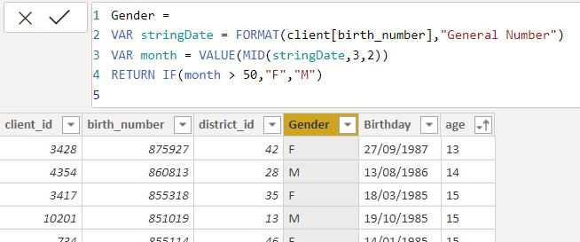

For birthday, we need to reduce the birth month of the female by 50 and then change the date format to DD/MM/YYYY adding 1900 to the year.

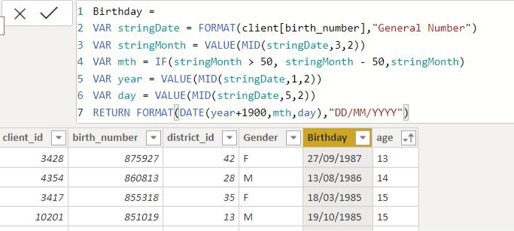

For Age, we shall assume it is year 1999 as explain previously and use it to minus from the birth year.

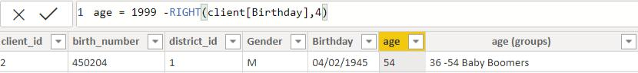

**Replacing values**

**© Edunet Foundation. All rights reserved** |12



Set some fields to English for easy understanding, we replace values to English with the Power Query Editor.

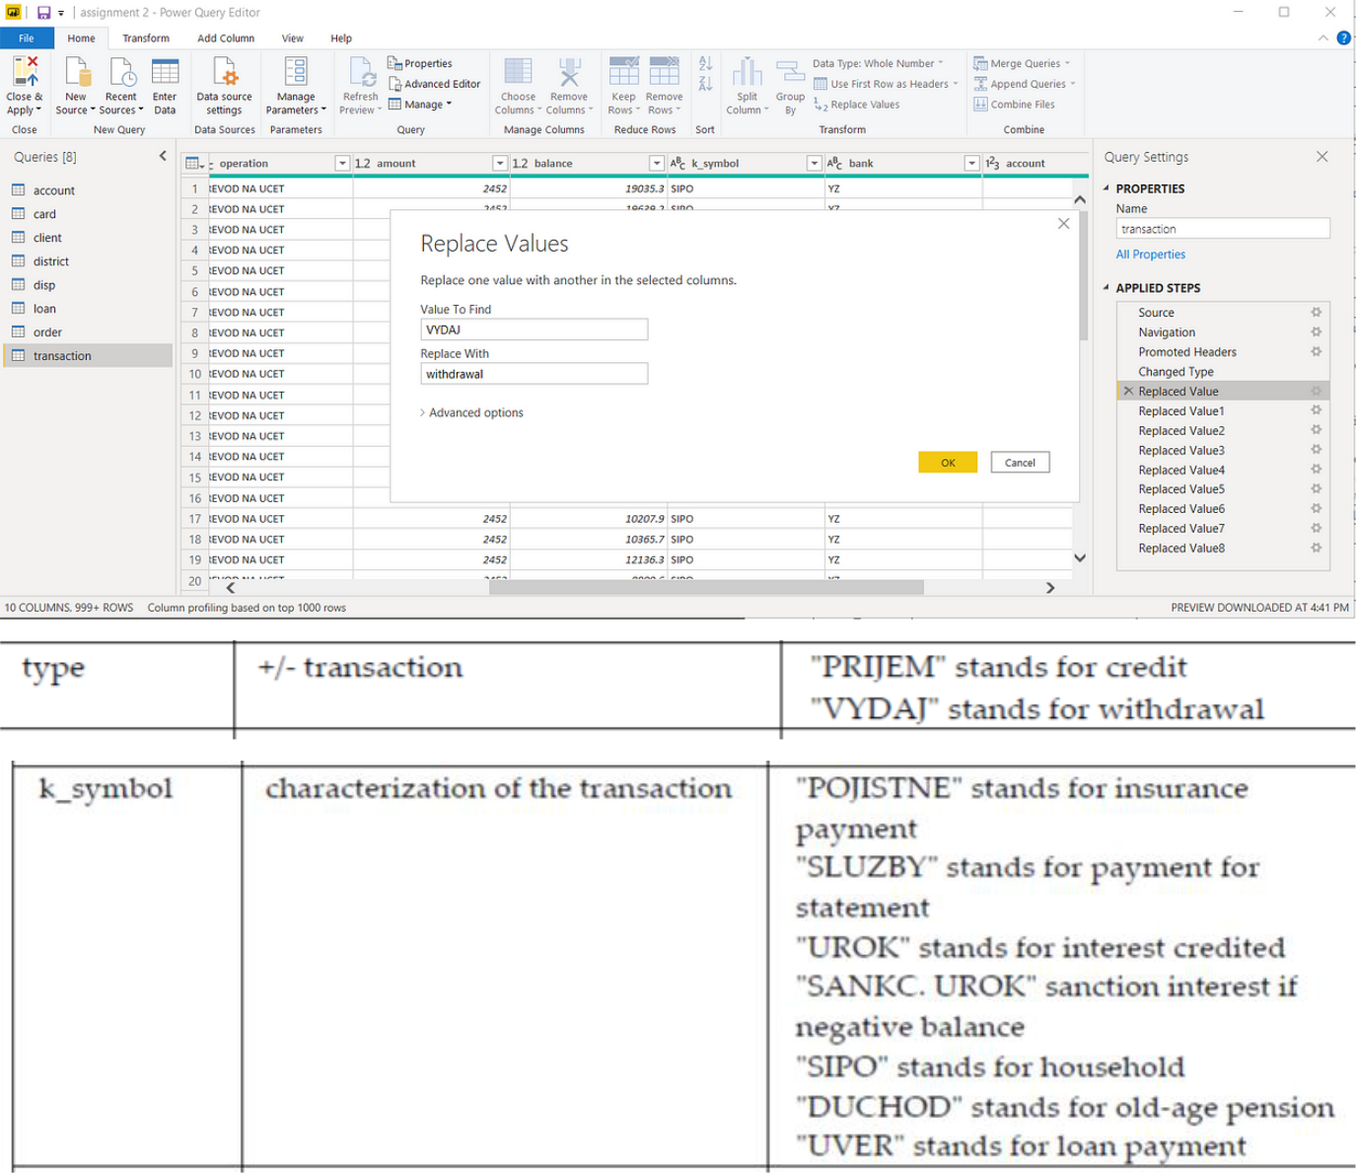

Changing the order of Region name at Power Query

Duplicate the “district /region” then split column using space as delimiter.

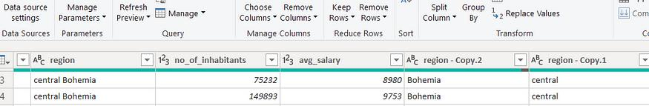

Then merge column by Region and direction. Refer to applied steps for details.

**© Edunet Foundation. All rights reserved** |13

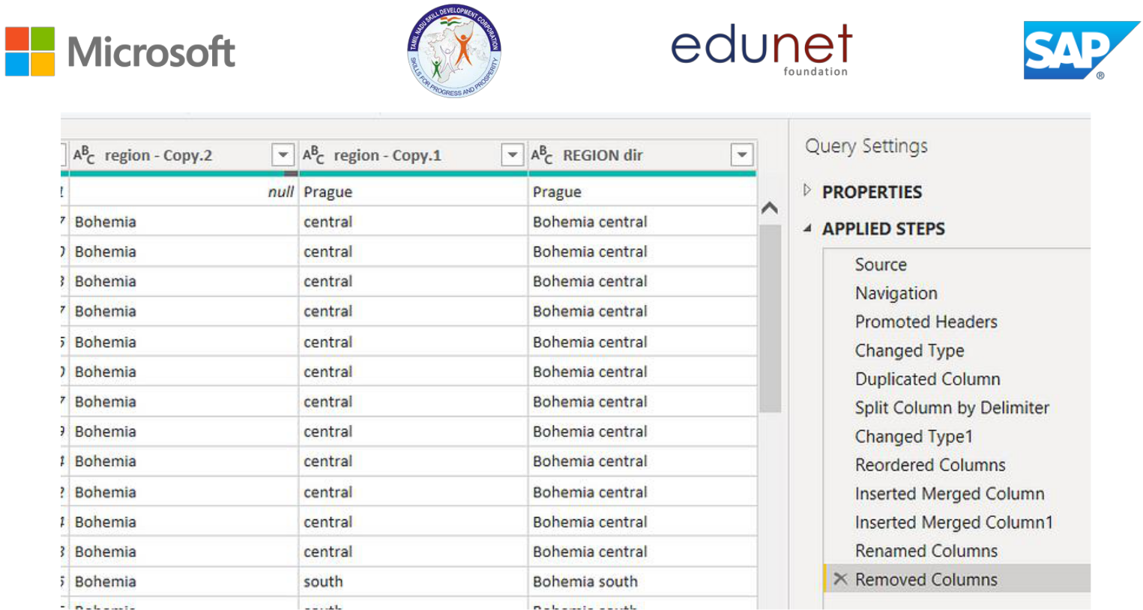

**Grouping of age by ranges**

As the customers’ age ranges from 12 to 88, we shall group them into different generation age range for easier profiling, we will group the ages into 5 groups. The Gen Y are youths,

Gen X are young working adults, some starting their families Baby Boomer are working adults with families.

The silent Generations some are working and retired, living on pensions.

The greatest Generation, retired elderly living on pensions.

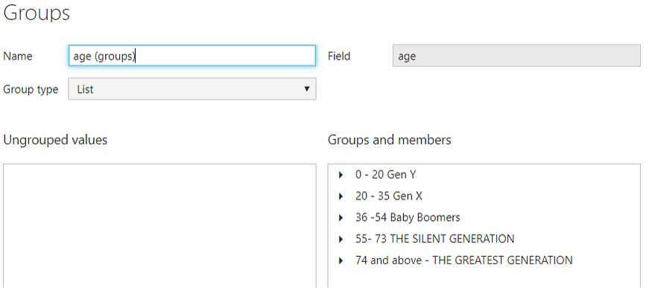

**Credit Rating and Loan Status**

**© Edunet Foundation. All rights reserved** |14



As the Loan status uses A, B, C, D which are not reader friendly. We can add a column to represent what it stands for, we also simplify the classification of those with late or default on payment as bad credit, refer to the table below for details on the new columns added.

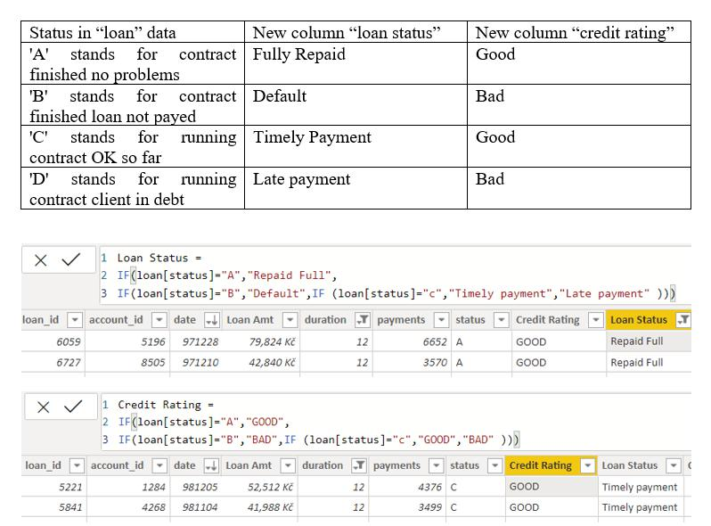

Values of such as “account Id” have also been set as Text.

And District name have been categorized as place to be use for the map to show the sum of the inhabitants in each region.

**© Edunet Foundation. All rights reserved** |15

**Dashboard**

## C:\Users\K.Karthik 3K\Downloads\IMG-20240328-WA0002.jpg

**CONCLUSION**

**Also highly informative, enabling stakeholders across the organization to make informed decisions based on real-time data. The "SUPPLY CHAIN OF ANALYTICS" initiative demonstrates the transformative power of integrating advanced analytics with business intelligence tools like PowerBI. By turning vast amounts of raw data into actionable insights, companies can optimize their operations, enhance customer satisfaction, and ultimately drive growth. This project exemplifies how leveraging the right technology and analytics strategy can uncover hidden opportunities and create a competitive advantage in the marketplace.**

**© Edunet Foundation. All rights reserved** |16



**FUTURE SCOPE**

**The expansion potential of this project is immense. By tapping into PowerBI's advanced analytics and machine learning features, we can vastly improve our ability to identify future trends based on historical data. This capability would enable the bank to anticipate customer needs and offer solutions proactively. PowerBI's ability to integrate with a variety of data sources enables the incorporation of diverse datasets, enriching our understanding of customer behaviors and preferences. As the importance of data privacy and security escalates, it's imperative that subsequent phases of the project focus on establishing robust data governance frameworks. This will safeguard sensitive customer information while complying with data protection regulations. Furthermore, integrating real-time data could transform customer interactions by providing immediate, actionable insights, potentially elevating customer satisfaction and loyalty**

.**© Edunet Foundation. All rights reserved** |17

**REFERENCES**

https://en.wikipedia.org/wiki/Product_management

.**© Edunet Foundation. All rights reserved** |18







**LINK**

<https://github.com/VEERAN-C/VEERAN-C.git>

**. All rig© Edunet Foundation hts reserved** |19